Participant Information Sheet |  | 
Study title: Neurofeedback for fibromyalgia.

Locality: Dunedin School of Medicine,  University of Otago, New Zealand. | Ethics committee ref.: 2023 EXP 15164
Lead investigator(s): Prof. Dirk De Ridder &  Dr. Divya Adhia  Student investigator: Lucy Anderson | Contact phone number: 022 101 1593

You are invited to take part in a study exploring the effect and evaluating the safety of a neurofeedback (brain wave training) technique for individuals with fibromyalgia. Whether or not you take part is your choice. If you don’t want to take part, you don’t have to give a reason, and it won’t affect the care you receive. If you do want to take part now, but change your mind later, you can pull out of the study at any time.

This Participant Information Sheet will help you decide if you would like to take part. It sets out why we are doing the study, what your participation would involve, what the benefits and risks to you might be, and what would happen after the study ends. We will go through this information with you and answer any questions you may have. You do not have to decide today whether or not you will participate in this study. Before you decide, you may want to talk about the study with other people, such as family, whānau, friends, or healthcare providers. Feel free to do this.

If you agree to take part in this study, you will be asked to sign the Consent Form on the last page of this document. You will be given a copy of both the Participant Information Sheet and the Consent Form to keep.

This document is 10 pages long, including the Consent Form. Please make sure you have read and understood all the pages.

Voluntary participation and withdrawal from this study
- Your participation in this study is voluntary.
- You may withdraw from this project at any time and without any disadvantage to you of any kind. Besides, the study staff may decide to withdraw you from the study if there are any side effects from the treatment or if they have any other concerns.

What is the purpose of the study?
The purpose of this study is to evaluate the safety and to explore the effect of a brain wave training (Neurofeedback) technique on pain and function in individuals with a diagnosis of fibromyalgia and arthritis. It will also provide information on the short-term and intermediate effects of this treatment on pain, function, and psychological measures. The neurofeedback technique can facilitate an individual’s ability to learn and self-control their brain activity in the selected brain regions, by providing real-time feedback. The computer system records the real-time electrical activity of the brain and provides sound feedback every time the activity of the selected brain region reaches a set threshold. This helps an individual’s brain to learn to self-control the electrical activity in the selected brain regions. This study will involve training the activity in the brain regions that have been demonstrated to be altered in individuals with fibromyalgia. The results obtained from this study will help us to develop new treatments for improving pain and function in individuals with fibromyalgia.

Who are We SEEKING TO PARTICIPATE IN THE PROJECT?
We are seeking ~30 adults (aged 18-75 years) with a clinical diagnosis of fibromyalgia. You are not eligible to participate if you have any of the following:

- Neurological conditions, cognitive and psychiatric disorders, unstable medical conditions
- History of epilepsy/seizures or alcohol or substance abuse (i.e., consuming >3 drinks on any day or >7 drinks per week for women, and >4 drinks on any day or >14 drinks per week for men).
- Presence of any pacemaker or defibrillator
- Recent or current pregnancy

You will be screened for the above-mentioned conditions by a researcher, either by phone or by email, to determine your eligibility to participate in this study. You will also be asked to provide contact details of your GP or other current provider. We will tell your GP or other current provider that you have agreed to take part in this study, and to inform them of any unusual findings that are recorded during assessments.

What will my participation in the study involve?
As shown in Picture 1, you will be required to attend the following four study phases
Before-treatment tests, Treatment phase, After-treatment tests, and Follow-up tests

Before-treatment tests
Questionnaires: pain, function, mood, sleep

Brain wave testing

Pain tests

Duration: Single session of ~1.5 hours
After-treatment tests

Questionnaires: pain, function, acceptability, satisfaction, mood sleep

Brain wave testing

Pain tests

Duration: Single session of ~1 hour

Follow Up-
tests

Questionnaires:
pain, function, mood, sleep

Brain wave testing

Pain tests

Duration: Two sessions of ~1.5 hours each

10 days following after-treatment tests
1 month following after-treatment tests

Treatment phase

You will receive either:
Neurofeedback to train two brain regions or
No neurofeedback

Duration: Three times a week for a total of 4 weeks
(i.e. 12 sessions in total)

Each session = ~1 hour

Picture 1. Study phases and time-commitment for each phase

Before-treatment tests: will take ~1.5 hours at the Dunedin hospital. The following tests will be conducted after obtaining written informed consent.

- Questionnaires: You will be asked to complete questionnaires about yourself (age, gender, education, ethnicity, well-being), and your pain (location, nature, intensity, type) and how much this affects your activities of daily living, quality of life and well-being, psychological states (e.g., mood, mindfulness, emotional regulation), current medication history (including pain relief), the presence of other health issues if any (e.g. diabetes), and sleep. You will also be asked about your thoughts associated with pain. Questionnaires may indicate that you would benefit from treatment in these areas, and our research team will discuss the findings with you, inform your GP/current healthcare provider, and make referrals to appropriate treatment providers.
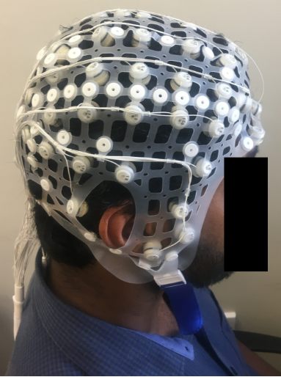
Picture 2. Brain wave testing cap with electrodes

- Brain wave testing: After completing the questionnaires, you will be asked to wear a cap with electrodes attached to it (see Picture 2). According to Tikanga Māori and Pacific culture, the head is considered sacred “he tapu te upoko” and the brain is regarded as the wairua (soul). The researcher will obtain permission from you before touching your head, and respect other cultural aspects (e.g., not sitting directly on pillows/tables; not passing food over anybody’s head, etc.). You will rest in a comfortable chair with your eyes closed for 10 minutes and your brain activity will be recorded.

The brain wave testing findings may indicate some abnormal waveforms and if these are detected, our research team will discuss the findings with you, inform your GP/current healthcare provider, and make referrals to appropriate assessment and treatment providers.

- Pain sensation testing: Following brain wave testing, simple test procedures recording your perception of pain sensation will be tested over your non-dominant wrist region (i.e. a non-painful body part for comparison purposes). The following test procedures will be administered.

- Repeated light touches with a thin and blunted nylon filament - You will be asked to tell us whether you are feeling a sensation of touch or of pain. If you feel pain on repeated contacts, you will be asked to rate your intensity of pain on a 0–100-point scale, where 0 = No pain and 100 = Worst imaginable pain.

- Pressure to pain sensation testing - Pressure will be gradually applied using a rubber-tipped pressure device. You will be asked to indicate immediately when the pressure sensation changes to discomfort or when you first feel pain.

Treatment phase:

- Randomisation: Following the before-treatment tests, you will be randomly assigned to receive one of the two treatment conditions as below:
- Neurofeedback to train two brain regions simultaneously
- No neurofeedback

You will have equal chances of being assigned to one of the two treatment groups, and you cannot change group.

- About Neurofeedback training: Neurofeedback is a form of brain training where your brain activity will be recorded through the electrode cap/machine in real-time. When your brain activity reaches a desired threshold, the machine will recognize and automatically provide a sound, as a reward. Your brain will spontaneously respond to the reward sound and will be able to maintain the state of brain activity around the threshold.

- Training sessions: You will be required to attend a total of twelve training sessions (1-hour each, three sessions per week, for four consecutive weeks), on the 6th floor of Dunedin hospital. At each session, you will have to wear a cap with electrodes attached to it on your head (see Picture 2). The researcher will ask permission before touching your head at each session. The researcher will apply electrode gel to your scalp to capture better signal quality. During this time, you will be asked to fill in some questionnaires about any side effects that you might have perceived from the previous sessions. Following the setup, you will receive treatment for 30 minutes at each session, while you rest (see Picture 3). You will be asked to close your eyes and relax for 30 minutes without falling asleep. If you are randomized to the treatment group, the neurofeedback computer program will play a distinct sound when your brain activity reaches the desired threshold. This distinct sound will be a reward for your achievement. If you are randomized to the placebo group, the set up and conditions will be identical except you will hear a pre-recorded session of sound feedback from a healthy participant instead of your own real time feedback.
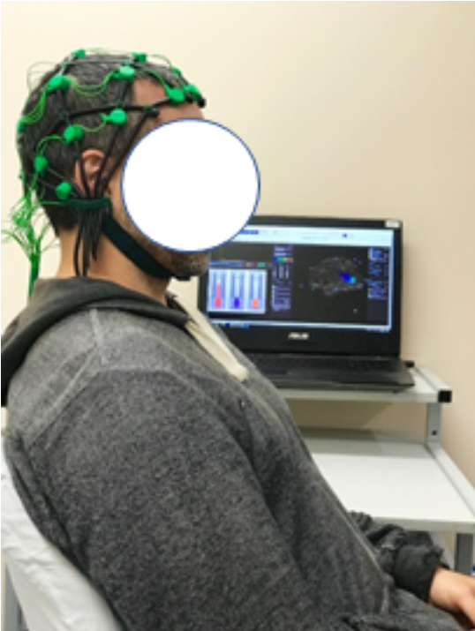

Picture 3. Neurofeedback treatment set-up

- Blinding: You and the researchers conducting the before-treatment tests will not know if you are receiving neurofeedback treatment or not, i.e., you will be blinded to the treatment you receive. This blinding will help us to find out whether any changes in the pain and function tests are due to the neurofeedback treatment itself.

After-treatment tests: will take ~1.5 hours at the Dunedin hospital. The same tests that were done before the treatment sessions will be repeated.

Follow-up tests: You will be required to attend two test sessions of ~1.5 hours at the Dunedin hospital, 10 days and 1 month following the after-treatment tests. The same tests that were done before the treatment sessions will be repeated.

What i can and cannot do during the study phases?
As electrical activity of the brain can be affected by various factors, we request that you don’t do the following:
- Drinking alcohol for 24 hours before the session
- Smoking for 4 hours before the session
- Consuming caffeinated drinks for 1 hour before the session
- Applying any hair products (oil, gel) before the session
You will be provided with some refreshments (e.g., crackers, tea, or juice) after each session.

What are the possible benefits and risks of this study?
Previous studies show that the neurofeedback treatment is a safe/effective method to manage chronic pain, in general. There are no known risk or adverse events associated with brain training used in this study. The common side-effects reported by previous studies can include headache and mood swings.

Your brain activity is recorded using the electrode cap, which is a safe and harmless procedure. Application of electrode gel may cause inconvenience.

For pain sensation testing, we do not anticipate any form of discomfort that would last following the test procedures. A slight reddening of the skin may stay following the pressure to pain sensation testing, and it should go within hours of testing.

Other risks include that there may be no benefits and the neurofeedback treatment may not improve your pain or functional levels, or any initial improvements may wear off.

You will be closely monitored for your responses during all the testing procedures, and sufficient rest will be provided between each testing procedure. Any side effects of the training will be formally recorded and addressed if medical attention is required.

Who pays for the study?
This study is funded internally funded by the University of Otago.

There will be no costs to you for participating in the study. You will receive in total $150 petrol vouchers at the end of the study as a reimbursement for your travel and parking expenses.

What if something goes wrong?
If you were injured in this study, you would be eligible to apply for compensation from ACC just as you would be if you were injured in an accident at work or at home. This does not mean that your claim will automatically be accepted. You will have to lodge a claim with ACC, which may take some time to assess. If your claim is accepted, you will receive funding to assist in your recovery.
If you have private health or life insurance, you may wish to check with your insurer that taking part in this study won’t affect your cover.

What happens after the study or if I change my mind?
During this study the research staff will record information about you and your study participation. This includes the results of various measures (e.g., pain symptoms, function, brain activity) by way of questionnaires, and assessments. If needed, information from your hospital records and your GP may also be collected. You cannot take part in this study if you do not consent to the collection of this information.

De-identified Information:

To make sure your personal information is kept confidential, information that identifies you will not be included in any report generated by the researcher. Instead, you will be identified by a code. The researcher will keep a list linking your code with your name, so that you can be identified by your coded data if needed.

The results of the study may be published in an international scientific journal or presented, but not in a form that would reasonably be expected to identify you. Only a summary of the data will be mentioned in the research publication. The data included in the publication will in no way be linked to any specific person, and your identity will not be recorded with the data. You are welcome to request a copy of the study results. These will be available in approximately February 2024.

Future Research Using Your Information:

If you agree, your deidentified information may be used for future research related to the brain stimulation intervention or brain activity. If you agree, your deidentified information may also be used for other medical and/or scientific research that is unrelated to the current study.

This future research may be conducted overseas. You will not be told when future research is undertaken using your information. Your information may be shared widely with other researchers. Your information may also be added to information from other studies, to form much larger sets of data. You will not get reports or other information about any research that is done using your information.

Your information may be used indefinitely for future research unless you withdraw your consent prior to the completion of the study.

Security and Storage of Your Information:

Your identifiable information is held at the University of Otago during the study. After the study it is transferred to a secure archiving site and stored for 10 years, then destroyed. Your coded information will be entered into electronic case report forms. Coded study information will be kept in secure, cloud-based storage indefinitely. All storage will comply with local and/or international data security guidelines.

Risks:

Although efforts will be made to protect your privacy, absolute confidentiality of your information cannot be guaranteed. Even with coded and anonymised information, there is no guarantee that you cannot be identified. The risk of people accessing and misusing your information (e.g., making it harder for you to get or keep a job or health insurance) is currently very small, but may increase in future as people find new ways of tracing information.

Rights to Access Your Information:

You have the right to request access to your information held by the research team. You also have the right to request that any information you disagree with is corrected.

Please ask if you would like to access the results of your brain wave tests during the study.

You may access other study-specific information before the study is over, but this could result in you being withdrawn from the study to protect the study’s scientific integrity.

If you have any questions about the collection and use of information about you, you should ask the researcher.

Rights to Withdraw Your Information:

You may withdraw your consent for the collection and use of your information at any time, by informing your Study Doctor.

If you withdraw your consent, your study participation will end, and the study team will stop collecting information from you.

If you agree, information collected up until your withdrawal from the study will continue to be used and included in the study. You may ask for it to be deleted when you withdraw unless you withdraw after the study analyses have been undertaken.

Who do I contact for more information or if I have concerns?
If you have any questions, concerns, or complaints about the study at any stage, you can contact:

Name: Dr. Divya Adhia  Position: Research Fellow  Department: Department of Surgical Sciences, University of Otago, Dunedin. | Phone number: 03 470 9337  Email: divya.adhia@otago.ac.nz
Name: Professor Dirk De Ridder  Position: Chair, Neurosurgery  Department: Department of Surgical Sciences, University of Otago, Dunedin. | Phone number: 03 470 9337  Email: dirk.deridder@otago.ac.nz
Name: Lucy Anderson  Position: Student  Department: Department of Surgical Sciences, University of Otago, Dunedin. | Phone number: 022 101 1593  Email: andlu456@student.otago.ac.nz

If you want to talk to someone who isn’t involved with the study, you can contact an independent health and disability advocate on:
Phone: 0800 555 050
Fax: 0800 2 SUPPORT (0800 2787 7678).
Email: advocacy@advocacy.org.nz
Website: https://www.advocacy.org.nz/

For Māori health support, please contact :

Name, position: Prof John Reynolds
Telephone number: 03 479 5781
Email: john.reynolds@otago.ac.nz

You can also contact the health and disability ethics committee (HDEC) that approved this study on:
Phone: 0800 4 ETHICS
Email: hdecs@health.govt.nz

This project has been reviewed and approved by the Health and Disability Ethics Committee (Ref: 2023 EXP 15164).

Consent Form

By signing this form, you indicate your consent to the following:

I have read, or have had read to me, and I understand the Participant Information Sheet.
I have had enough time to think about whether or not to participate in this study.
I have had a chance to use a legal representative, whanau/ family support, or a friend to help me ask questions and understand the study.
I am happy with the answers I have been given regarding the study, and I have a copy of this consent form and information sheet.
I understand that taking part in this study is voluntary (my choice) and that I may pull out from the study at any time without this affecting my medical care.
I understand the risks associated with the testing and treatment procedures, which are explained in the Participant Information Sheet.
I understand that my participation in this study is confidential and that no material, which could identify me personally, will be used in any reports on this study.
I know that I will be given petrol vouchers (a value of 150$) to cover travel expenses associated with study participation.
I understand the compensation provisions in case of injury during the study.
I know whom to contact if I have any questions about the study in general.
I understand my responsibilities as a study participant.
I agree with my GP or other current provider being informed of my participation in this study.
I agree for the researchers to contact my GP or other current provider if needed to determine my eligibility for participation in the study, and to be notified if any incidental findings is recorded.
I agree to an approved auditor appointed by the New Zealand Health and Disability Ethics Committee, or any relevant regulatory authority or their approved representative reviewing my relevant medical records for the sole purpose of checking the accuracy of the information recorded for the study.
I understand that the data collected from me in this study may be used for other future medical and/or scientific research that is unrelated to the current study. | Yes □ | No □
I wish to receive a summary of the results of the study. | Yes □ | No □

Declaration by participant:

I hereby consent to take part in this study.

Participant’s name:

Signature: | Date:

Emergency contact / Support person:

Please specify a contact person (a friend or a relative), in case of an emergency during the study participation. The contact details will be deleted from the file following completion of the study phases.

Name of a friend or relative:

Contact number:

Declaration by a member of the research team:

I have given a verbal explanation of the research project to the participant and have answered the participant’s questions about it.

I believe that the participant understands the study and has given informed consent to participate.

Researcher’s name:

Signature: | Date:

